NSTA GIS platform changes

What's happening?
The NSTA has upgraded its GIS platform and has moved to a new architecture. Therefore, our services are now hosted on ArcGIS Online instead of our own ArcGIS servers, so the URLs for the data have changed. The URL addresses for our interactive maps have also changed as a result.

Why is it happening?
We have moved to an ArcGIS Online-hosted solution. As well as being the Esri-recommended approach for our ArcGIS platform, we hope this will lead to a more reliable, streamlined Open Data experience including additional formats for data download.

When is it happening?
The new platform was published on the 22nd of September 2025.

What do I need to do?
As the URLs and APIs have changed as a result of this migration, you will need to update any internal links to continue to use these services. We have provided look up tables of the new links for our products and datasets. These are linked here and through the document below:
- GIS Services
- Dataset Schema
- Maps and Apps

Please note there will be an 8-week period starting the 22nd of September 2025 where both the old and new platforms will be running simultaneously to allow users time to make the necessary changes before the old platform is decommissioned.
The old services and open data site will start decommissioning the week of 17th November.
If you have any questions, please contact the GIS team: gis@nstauthority.co.uk.

Open Data site URL changes
Action Required: Be ready to update/replace existing bookmarks accordingly.
Details:
The following URLs have been updated. Please replace any existing bookmarks when these changes take effect:
Page | Old | New
ArcGIS Online (AGOL) organisation | https://nstauthority.maps.arcgis.com/home/index.html | https://ukcs-transition.maps.arcgis.com/home/index.html
Open Data site | https://opendata-nstauthority.hub.arcgis.com/search | https://open-data-ukcs-transition.hub.arcgis.com/search

Dataset layer structure changes
Action Required: If you have projects or processes that currently rely on grouped layers, change them accordingly.
Details:
Previously, multiple data layers were grouped. For example, UKCS_Wells_WGS84 had the layers top holes, bottom holes and straight-line connections in one feature service layer.
Each dataset is now in individual layers with unique IDs.
Example within ArcGIS Pro:
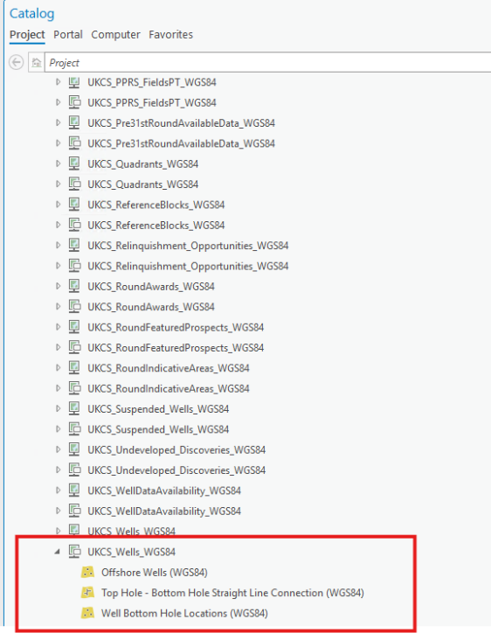 | 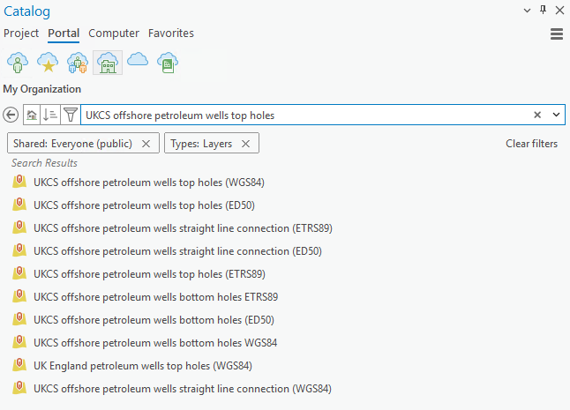

Example within Open Data:
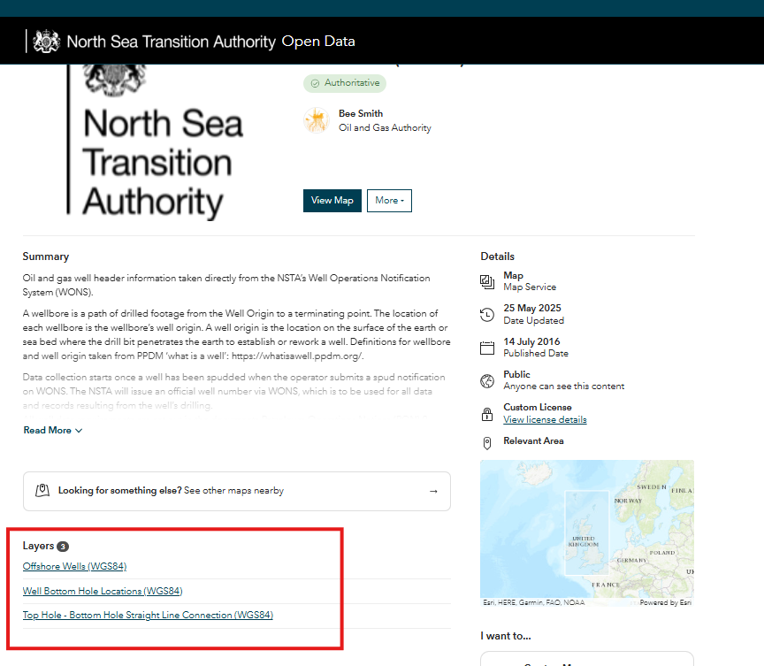 | 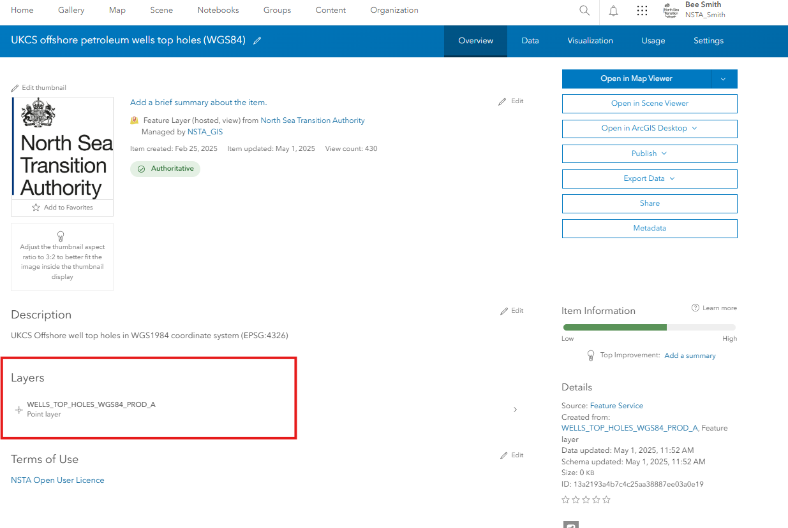

Example within REST services for scripts:
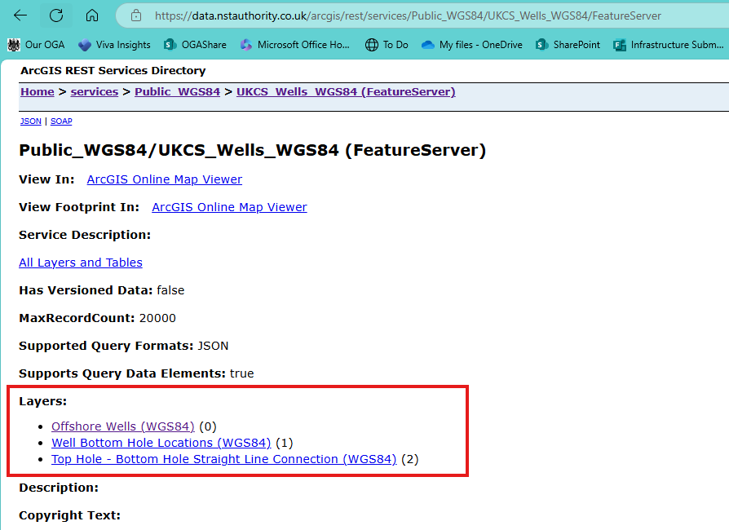 | 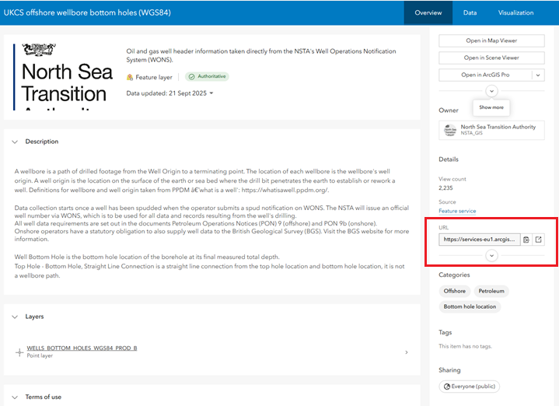

Improved dataset naming
Action Required: if your scripts or processes depend on layer names, these may now be different. The look up table for the new layer names can be found HERE.
Details:
To enhance clarity, we have standardised layer naming:
- Old Name: UKCS_Offshore_FieldDets_ED50
- New Name: UKCS petroleum field determinations (ED50)

Attribute field name updates
Action Required: If your scripts or processes rely on specific field names, you will need to update them. The look up table for the dataset schemas can be found HERE.
Details: All externally available datasets have been updated as below:
- 10-character limit for attribute field names.
- All attribute field names are now in capital letters.
- Fully qualified alias names are present for all datasets.

Changes to interactive maps and dashboards – renamed & updated
Action Required: You will need to update any bookmarks and references to the new URLs and application names.
The look up table for the new URLs and application names can be found HERE.
All interactive maps and spatial dashboards (Interactive maps and dashboards) have been updated with a new name and new URL. Other types of applications, such as Power BI reports, the wellbore search and the licence list page have not changed.

